3-17-00 Policy

10 Procedures

20 Guidance and Information

30 Reporting Requirements

**3-17-00 POLICY**

This Section provides instructions for managing contractor access to the Clinical Center Complex (CCC): (Buildings 10 and 10B, Mark O. Hatfield Clinical Research Center (CRC), and the INVIVO (NMR) Addition) to perform authorized work in compliance with The Joint Commission (TJC) safety and security risk guidelines for facilities and the supporting utility infrastructure.

The SPEP is designed to manage the potential security risk to CCC through use of a standardized screening process to ensure authorized access to the CC facility.

##### **A. APPLICABILITY**

This policy applies to the numerous contractors performing construction, maintenance and operational activities required to support CC functions to maintain safety and reliability of CC facilities.

##### **B. RESPONSIBILITIES**

1. The **Office of Research Facilities (ORF)** is responsible for the management and coordination of facility maintenance, operations and construction efforts to ensure compliance with the TJC Environment of Care (EC) Standards to minimize adverse impact to occupants, patients and hospital operations.
2. The **ORF, Office of Hospital Physical Environment (OHPE)** is responsible for implementing and providing oversight of the SPEP and communicates with PO’s to resolve compliance issues.
3. The **ORF, Division of Design Construction Management (DDCM)** is responsible for ensuring construction contracts identify the SPEP requirement and ensures contractors have received ORFDO’s Joint Commission training prior to the start of work in the CCC.
4. The **ORF, Office of the Director (OD)** is responsible for providing Joint Commission training to contractors and maintenance personnel scheduled to perform work in the CCC.
5. The **Clinical Center Hospital Engineering and Facility Services (CCHEFS) and Institutes & Centers (ICs)** are responsible for:
   1. Identifying contractors performing work in the CCC;
   2. Making sure contractors are aware of the SPE Policy; and
   3. Contractors obtain ORFDO’s Joint Commission training prior to starting work.

**3-17-10 PROCEDURES**

1. All contractor personnel accessing the CCC to perform work must to adhere to the following procedures and as outlined in Appendix A:
2. At least two weeks prior to the start of work or at any time personnel changes (replacement, addition or removal) are made, contractors must provide the ORF Project officer (PO) or Contracting Officer Representative (COR) the list of personnel scheduled to work in the CCC.
3. The ORF PO or COR ensures that all contractor personnel receive ORF’s Joint Commission (JC) training and provides the list of all qualified and trained personnel to the OHPE SPE Coordinator.
4. Contractor must issue a work specific ID badge (Appendix B) to each authorized personnel.
5. All contractor personnel must enter the CCC through the **Single Point of Entry (SPE) in Room B2A17A at the B-2 loading dock,** located at the southeast end of Building 10 (Appendix C). An identification badge and proof of receipt of ORFDO’s JC training is required prior to entrance being granted to the CCC.
6. Upon entering the CCC, all contractor personnel must report directly to the authorized work site and display an ID badge at all times.
7. If contractor personnel fail to use the SPE, they will be asked to immediately leave the CCC and will not be allowed access until reinstated by the PO or COR through SPE Coordinator.

**3-17-20 GUIDANCE AND INFORMATION**

A. RELATED ACCREDITATION STANDARD

1. The Joint Commission (TJC) Environment of Care (EC) Standard EC.02.01.01 - The hospital manages safety and security risks

##### B. RELATED DOCUMENTS

1. [CC General Administrative Series Policy S-002, “CC Security Risk Management in the Hospital”](https://cc-internal.cc.nih.gov/AdminPolicies/PDF/S-002%20Security%20Risk%20Management%20in%20the%20Hospital%2005252018.pdf)
2. [NIH Policy Manual 1381 – Physical Security Project Requirements for NIH Owned and Leased Facilities](https://policymanual.nih.gov/1381)

##### C. RECORDS

1. ORF/OHPE SPEP database that track and monitor compliance with EC standards.

**3-17-30 REPORTING REQUIREMENTS**

1. ORF/OHPE provides EC standards compliance tracking and monitoring report for PO’s/COR’s and contractors.
2. ORF/OHPE short-term and long-term Plan of Action to mitigate EC compliance risks in consultation with the CC and ORF leadership.

**Appendix A**



Clinical Center Complex(CCC) ORF Contractor Single Point of Entry Flow Diagram - Accessible Version

**Appendix B**

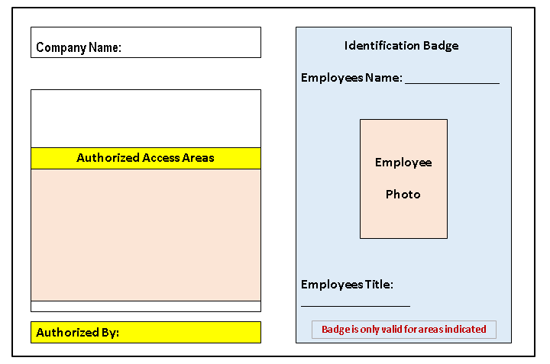

**Appendix C**

Emphasis placed on the Security Check Point 